**What is Data ?**

Data is nothing but facts and statistics stored or free flowing over a network, generally it's raw and unprocessed. For example: When you visit any website, they might store you IP address, that is data, in return they might add a cookie in your browser, marking you that you visited the website, that is data, your name, it's data, your age, it's data.

Data becomes information when it is processed, turning it into something meaningful. Like, based on the cookie data saved on user's browser, if a website can analyze that generally men of age 20-25 visit us more, that is information, derived from the data collected.

**What is Database?**

Database is a collection of organized data in way that can be easily accessed , managed and updated. Database can be of software based or hardware based.

**Categories of Database :**

Software Based Databases are:

MySQL Workbench , Mongodb, Microsoft azure SQL database, oracle, IBM db2, Postgre SQL.

Hardware Based Databases are:

Flash storage

**Types of databases?**

1. **Centralized Databases :** A centralized database is like a single vault of information, all stored in one place and accessed by many.

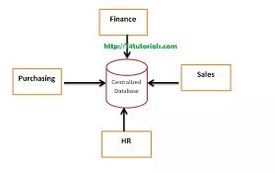

**Eg**. Disadvantage:

* Bottle Neck Kind……Speed and processing power becomes less….Takes Requests fast but responds slowly
  + Less Reliable/trustworthy as if central database fails , our whole data will be lost

Eg. Dekstop or Server CPU

1. **Distributed Databases :** A distributed database system is a collection of multiple , Logically related database over a network, that are physically distributed.

Advantage : Its Most Reliable/most trustworthy , as if one system fails .. then data may be retrieved from other system …in this system there is no bottle neck concept

Better response, Less communication cost , Easily expandable

Eg. Amazon Web Service

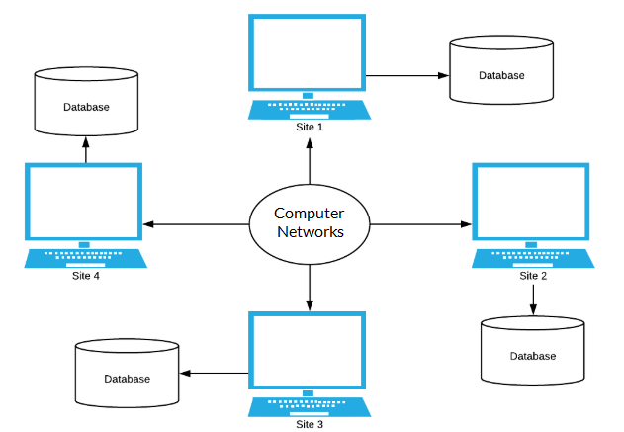

1. **Object Oriented Database :** In Object Oriented Databse, Real word problems are represented as object , with different attributes . All these objects have multiple relationship between them.

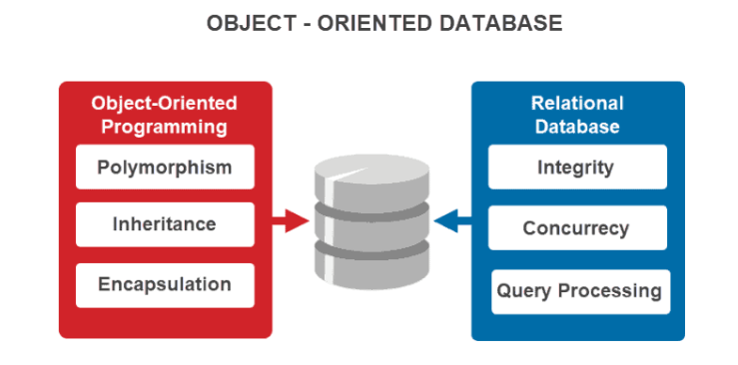

Example : **Call detail records (CDRs):** OODBs manage massive amounts of call data for billing, customer analysis, and network planning purposes, handling complex relationships between subscribers, calls, services, and network resources.

Trading positions etc

1. **Cloud Database :** A cloud database is a database that is hosted on a cloud computing platform, such as **Amazon Web Services, Microsoft Azure, or Google Cloud Platform**. It enables users to store, manage, and access data through the Internet. The data is stored in a remote server
2. **Network Database :** A network database is a database on a network containing information accessible by multiple clients through a network at the same time. It is similar almost similar to hierarchical databse

Eg. Follows Child-parent relationship , CRM (customer relationship management system.)

1. **NoSQL Database :** As its name suggests , Not only SQL as storing data in a tabular format it mainly stores data in a dictionary format which is a kind of key value pair .

**Document Oriented database –** A types of database used to store data as JSON like document

**Wide-Column Storage –** Similar to Relational Databases , here data is stored in large column together , instead of storing in rows.

**Eg:**- MongoDB , Cassendra

1. **Relational Databases :** A relational databases are the databases which stores data in a tabular format like in the form of rows and columns , maintaining a sequential relationship among data.

**eg.** Microsoft SQL Server, Oracle Database, MySQL, IBM DB2,SQlite3,PostgreSQL

**Terminologies used in Relational Databases**

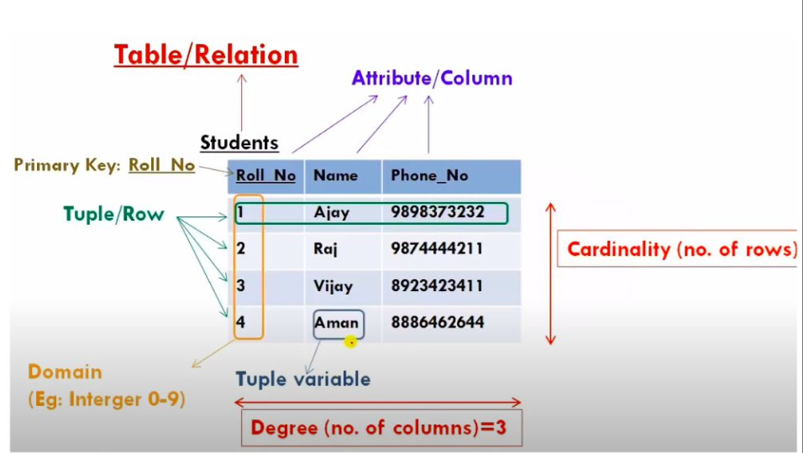

**Rows** -🡪Tuple/ Record

**Columns -**🡪Attributes (characteristics of data stored in a column)/ Field

**Schema** -🡪 Column Names or a database schema is a logical representation of data.

**Domain** -🡪 A set of an atomic values that are allowed for an attributes, Domain also specifies the data type allowed to a particular tuple.

**Atomic values** : Each Value in that domain is not divisible further

**Eg**. Name, Id, Age ( Possible ages of employee of a company is allowed between 20-70 )